|  |  |
| --- | --- |
| **Class:** | DISM1A05 |
| **Student ID:** | 2006264 |
| **Name:** | Soh Kai Meng Leonard |
| **Practical Number:** | Practical 01 |

**Practical 01  
Identify the components of a personal computer (PC)**

In this practical, you will examine the motherboards of some personal computers and learn to categorize the components indicated in the pictures as:

1. Central Processing Unit (CPU) [ALU + Control Logic]
2. Memory
3. CPU Cache
4. Input/output, Network Interface Card
5. **Identifying the CPU of your own PC**
6. To find the exact processor model on your Windows 10 or Windows 8.1 computer, you can look for ‘***System Information***’ in search. On the detailed system informationpanel, you can identify the model of the processor (look for the model number).

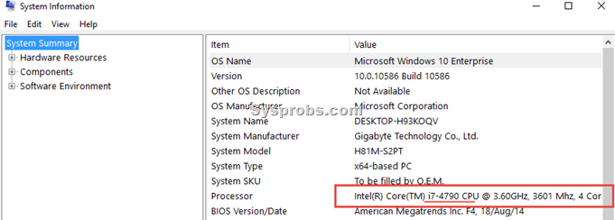

1. Write down your observation:

|  |  |
| --- | --- |
| **System Type (32bit or 64bit)** | **64 bit** |
| **Processor Model** | **Intel(R) Core(TM) i7-10510U CPU @ 1.80Ghz, 2304 Mhz, 4 Core(s), 8 Logical Processor(s)** |
| **Number of CORES** | **4** |

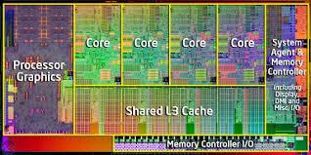-10

1. **Identifying the Memory of your own PC**
   1. Observe and write down the physical memory: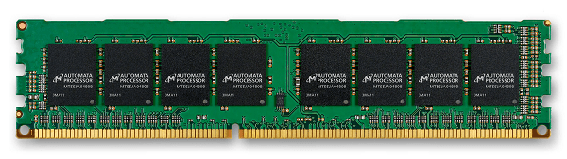

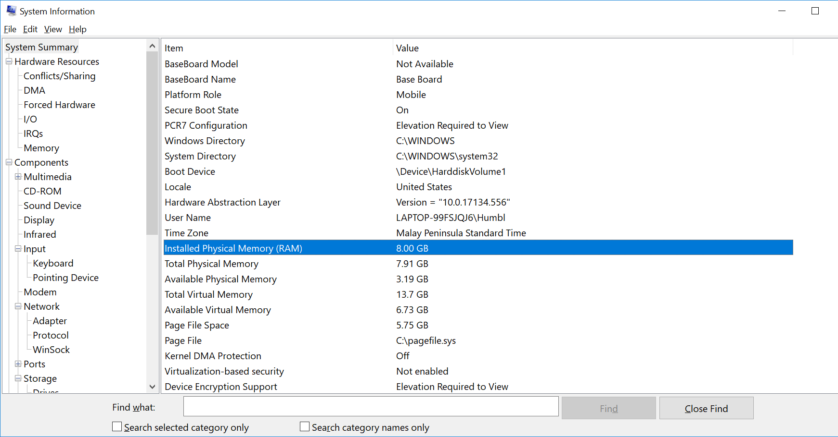

|  |  |
| --- | --- |
| **Size of the physical memory** | **16 GB** |
|  |  |

|  |
| --- |
| Memory capacity: The more gigabytes (GB) your memory module has, the more programs you can have open at once.   * 2-4 GB. This was the standard RAM capacity and shipped with systems running Windows Vista or XP. This amount of memory could handle single applications. If your system has less than 4GB of RAM, adding more RAM would greatly improve its performance. * 4-6 GB. This standard RAM capacity will handle an average user's tasks, such as web browsing, working in Word documents, and emailing, with ease. * 6-8 GB. This larger RAM capacity works great for casual gamers and basic multimedia users. It can handle multiple programs open at one time and new technology so that users don't have to upgrade when their needs change. * 8+ GB. This robust RAM capacity is perfect for hardcore gamers and high-end multimedia users and creators. These users want to try the newest technology on the market without upgrading their RAM. |

Memory Speed: The amount of time that it takes RAM to receive a request from the processor and then read or write data. Generally, the faster the RAM, the faster the processing speed.

Search google to find the Speed of typical physical memory for your PC.

RAM speed is measured in Megahertz (MHz), millions of cycles per second, so that it can be compared to your processor's clock speed

1. **CPU Cache**
   1. Based on the model of the processor in previous step, search google for the CPU model, take note of the CPU CACHE size

|  |  |
| --- | --- |
| **CPU Cache size** |  |
| **Level 1 Cache 256KB**  **Level 2 Cache 1MB**  **Level 3 Cache 8MB** |  |
|  |  |

* 1. Download and install cpu-z from [**https://www.cpuid.com/downloads/cpu-z/cpu-z_1.87-en.exe**](https://www.cpuid.com/downloads/cpu-z/cpu-z_1.87-en.exe)
  2. Check the CPU Cache size:

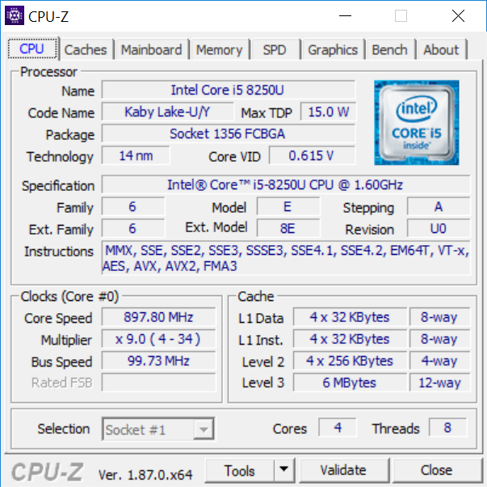

* 1. Take note and write down the Cache size:

|  |  |
| --- | --- |
| **L1 Data** | **32 KBytes x 4** |
| **L1 Inst** | **32 KBytes x 4** |
| **Level 2** | **256 KBytes x 4** |
| **Level 3** | **8 MBytes x 4** |

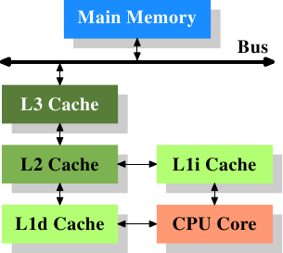

**Explain how CPU cache can enhance the computer speed by referring to the picture:**

|  |
| --- |
| **Explain how CPU cache can enhance the computer speed** |
| **CPU Cache holds copies of data that is frequently accessed. Since ram takes a longer time than CPU cache to send data, the CPU cache will enhance the speed of the computer as it is able to send the data to the CPU faster than the ram.** |

* 1. RAM upgrades are limited by the capability of the system and the availability of expansion slots for adding RAM. Check if you have expanded RAM on your computer.  
       
     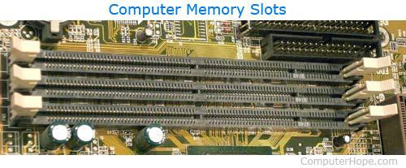

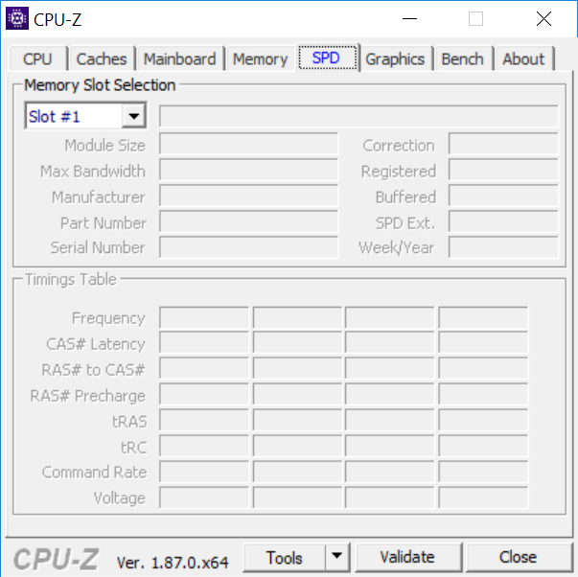

|  |
| --- |
| **How many slots are used for memory expansion?** |
| **2** |

1. **Network Interface Card**

## Ethernet Card

Ethernet card, also known as network interface card (NIC), is a hardware component used by computers to connect to Ethernet LAN and communicate with other devices on the LAN. The earliest Ethernet cards were external to the system and needed to be installed manually. In modern computer systems, it is an internal hardware component. The NIC has RJ45 socketwhere network cable is physically plugged in.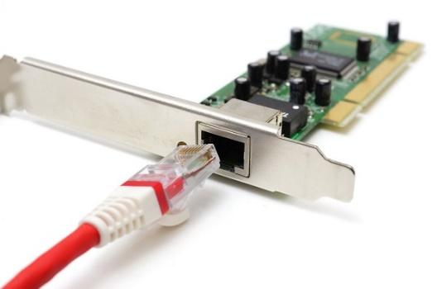

1. Go to command window by typing run cmd

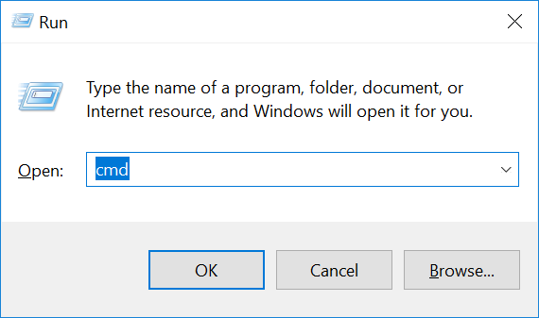

1. Type the following command in the command window

|  |
| --- |
| systeminfo |

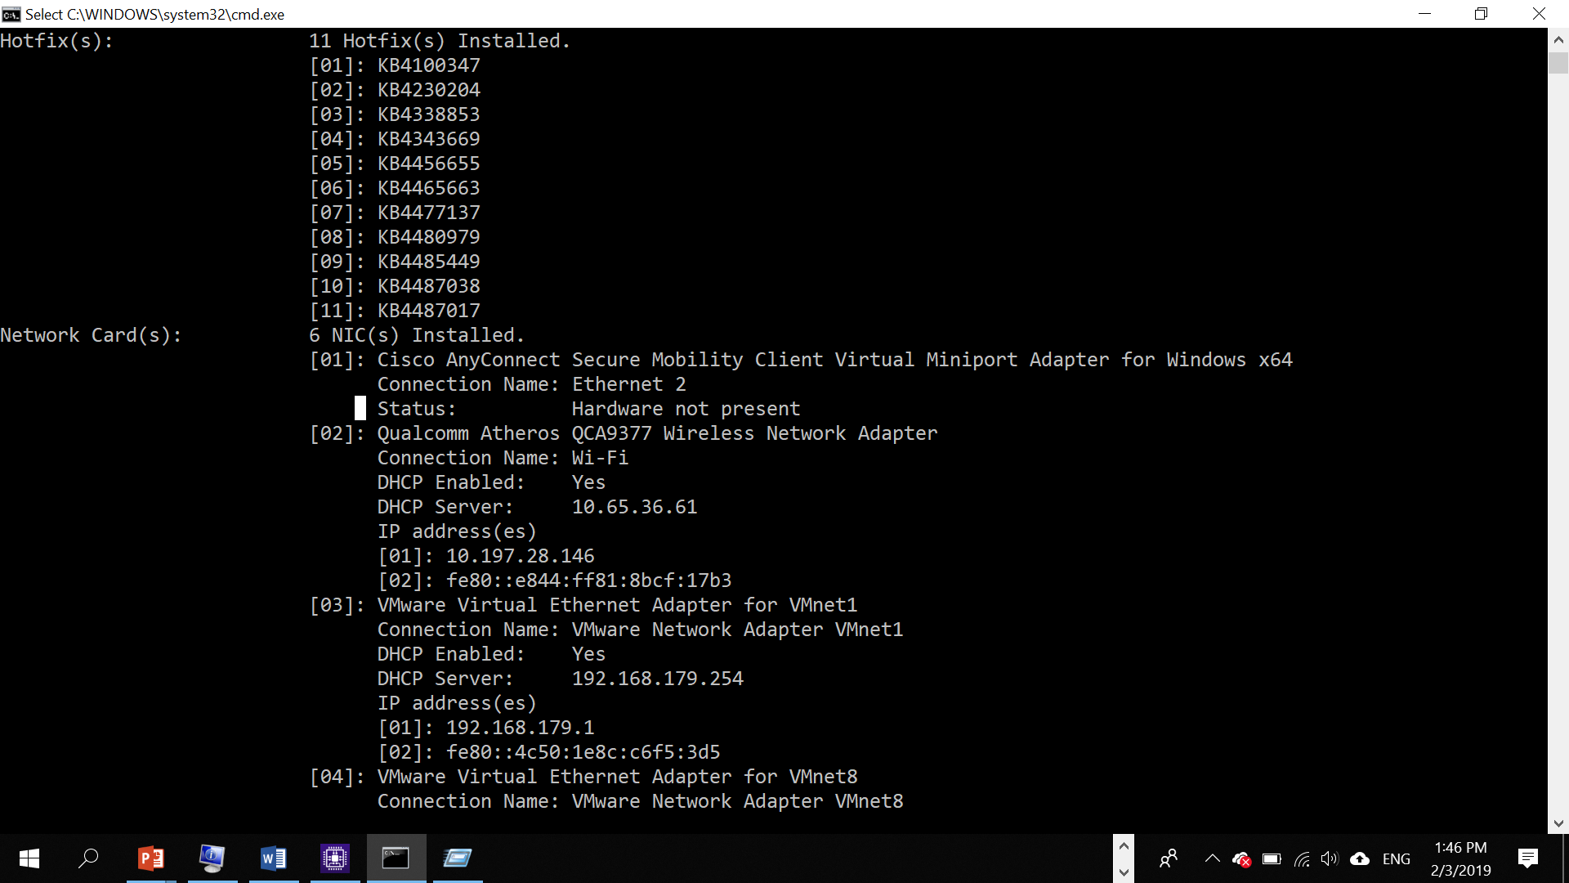

[01]: Intel(R) Wireless-AC 9560 160MHz

Connection Name: Wi-Fi

DHCP Enabled: Yes

DHCP Server: 164.78.28.74

IP address(es)

[01]: 172.22.67.57

[02]: fe80::956:bf32:99c3:ab91

Type the command:

|  |
| --- |
| ipconfig /all |

1. Observe the result and record down:

Wireless LAN adapter Wi-Fi:

Connection-specific DNS Suffix . : student.sp.edu.sg

Description . . . . . . . . . . . : Intel(R) Wireless-AC 9560 160MHz

Physical Address. . . . . . . . . : C8-09-A8-CD-F5-B9

DHCP Enabled. . . . . . . . . . . : Yes

Autoconfiguration Enabled . . . . : Yes

Link-local IPv6 Address . . . . . : fe80::956:bf32:99c3:ab91%4(Preferred)

IPv4 Address. . . . . . . . . . . : 172.22.67.57(Preferred)

Subnet Mask . . . . . . . . . . . : 255.255.248.0

Lease Obtained. . . . . . . . . . : Wednesday, 21 April 2021 7:56:55 am

Lease Expires . . . . . . . . . . : Wednesday, 21 April 2021 2:30:56 pm

Default Gateway . . . . . . . . . : 172.22.64.1

DHCP Server . . . . . . . . . . . : 164.78.28.74

DHCPv6 IAID . . . . . . . . . . . : 63441320

DHCPv6 Client DUID. . . . . . . . : 00-01-00-01-27-23-6E-83-C8-09-A8-CD-F5-B9

DNS Servers . . . . . . . . . . . : 172.25.25.111

172.25.25.112

Primary WINS Server . . . . . . . : 172.25.25.111

Secondary WINS Server . . . . . . : 172.25.25.112

NetBIOS over Tcpip. . . . . . . . : Enabled

|  |  |
| --- | --- |
| **Wireless NIC model** |  |
| **Model** | Intel(R) Wireless-AC 9560 160MHz |
| **IP address** | 172.22.67.57 |
| **MAC Address** | C8-09-A8-CD-F5-B9 |

1. Based on the model of wireless NIC, find the image of the card, for example: 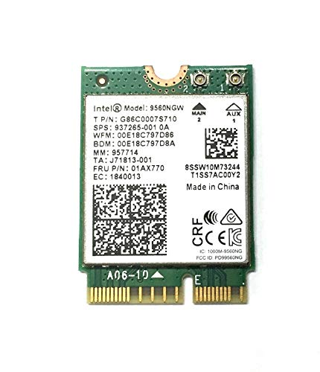

|  |
| --- |
| **Google Search for the following:**  How many bytes for MAC address?   * 6 byes   What is MAC address for?   * It is a unique identifier assigned to a network interface controller for use as a network address in communications within networks.   If you change a new Wifi Card, will your MAC address also change?   * Yes, the MAC address will also change. This is because each Network Interface Card has a unique MAC address assigned to it that separates it from every other network. Thus, by changing the Wifi card, the MAC address will also change. |

1. What have you learnt?

Today, I have learnt a lot about the system my computer is running on. From the CPU to how data is being transferred from the different levels of CPU Cache to the CPU or RAM to CPU.

4. Difficulties encountered and how you solved the problems?

There were generally no difficulties I encountered in this practical. Every set of instructions were easy to understand and follow.